 **Bursary donors and partners**

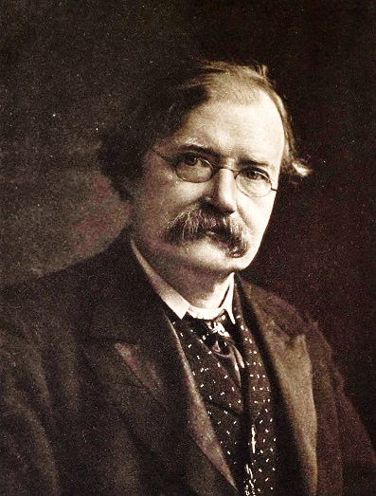

**John Churton Collins (1848-1908)**

John Churton Collins was a literary critic who taught in continuing education contexts for much of his career and wrote books and reviews on a wide variety of subjects, including ethics and literature, and studies of Swift, Shakespeare and Tennyson.

His work was combative and often divided opinion: Tennyson disliked Churton Collins’ dissection of the sources of his poetry so much that he described him as ‘a louse on the locks of literature’. While his own life was not always easy, he is remembered fondly in his son’s 1912 memoir as an erudite and kind teacher. One student who had attended his lecture series on the poetry of Browning wrote to thank him, noting that Browning seems to be a poet ‘especially helpful to those in middle life’ and saying:

“My gratitude to you is very deep, for you have that rare gift of imparting some of your wonderful stores of knowledge so as to enrich your hearers. Instead of feeling my own want of education more keenly, you draw out all that I possess and at the end of each lecture give some magic oil to keep alive the feeble flame at home.”

He supported the study of English in its own right as a University discipline when the subject was still in its infancy, but was anxious that knowledge of classical literature should be part of a literary education. It was therefore fitting that his friends the founded prizes in his memory at the Universities of London, Birmingham and Cambridge for the encouragement of English and classical study among university extension students.